Report for Compiler Lab

Compiler: A compiler is a program that can read a program in one language (the source language) and translate it into an equivalent program in another language (the target language).

Source program → Compiler → Target program

**Lab No: 01**

Problem Statement: Remove single line and multiline comment**.**

**Description**: At first, we are taking a program as input using file system. Then we have to delete single line and multiline comment from that input program. We have to check one condition for remove single line comment and check two condition for multiline comment. For single line comment, we are simply checking the character of ith position and (i+1)th position in a line are respectively ‘/’ and ‘/’ or not. If we get “//”, we set the flag value 1 for stopping print the characters after “//”. For multiline comment, we are checking two condition. First condition is the character of ith position and (i+1)th position in a line are respectively ‘/’ and ‘*’ or not. If we get “/*” we set the flag value 1 for stopping print the characters after **“**/*”. The second condition is for finding the end of the multiline comment. In the second condition we will check the character of ith position and (i+1)th position in a line are respectively ‘*’ and ‘/’ or not. If we get “*/”, then we set the flag value 0 for printing the characters after “*/”.

Input: 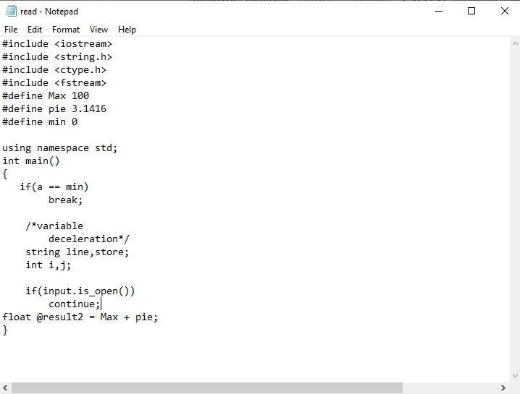Output: 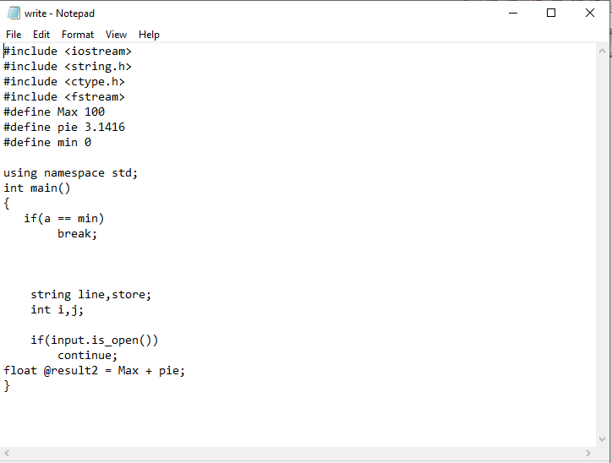

**Lab No: 02**

Problem Statement: Print all Special character in a given program as input.

Description: At first, we are taking a program as input using file system. For identify all the special character or symbol at first we have declare a char type array which contain all the special character. Then we have check one condition for identify special character. The condition is, the ith position is equal to any index data of the char type array or not. We have another array which contain all the symbols name respectively. When the condition will satisfy with any ith position, the corresponding value of ith position in the symbol name array will be print.

Input:



Output:

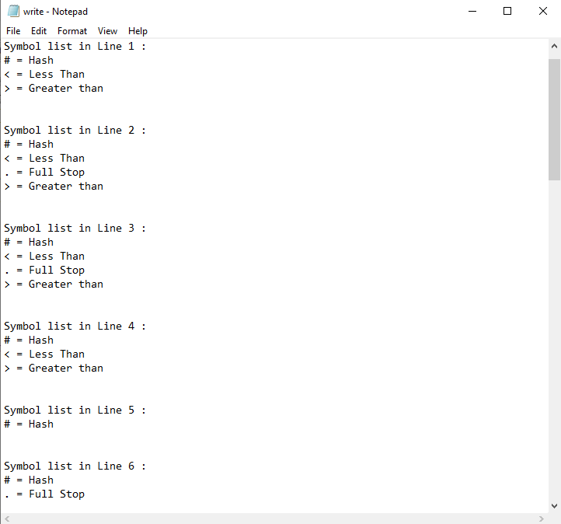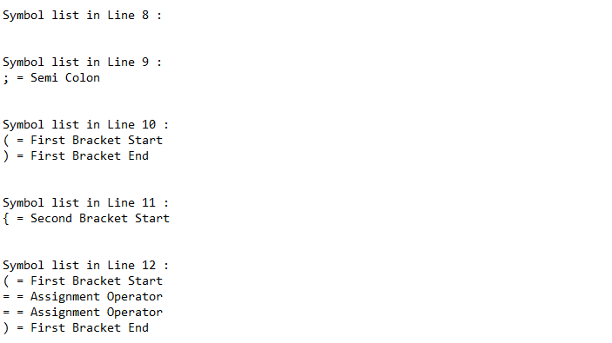

**Lab No- 03**

Problem Statement: Assign constant value instead of constant name.

Description: At first, we are taking a program as input using file system. To solve this problem, firstly we have to check “#define” word is exist or not in any line of the input program. If exist, then we have to take all character after the space of #define. We will take character till next space and all these character will be concate in a string type array index. This is the constant name and after that space, we have to concate all the character until space or garbage value in another string type array index. This is the constant value. Similarly all the constant name and value will be added in that two array with same position. After that, we have to check where the constant name has been used. When we get the constant name anywhere of the input program, simply we will replace the name with constant value and print all lines.

Input:



Output:

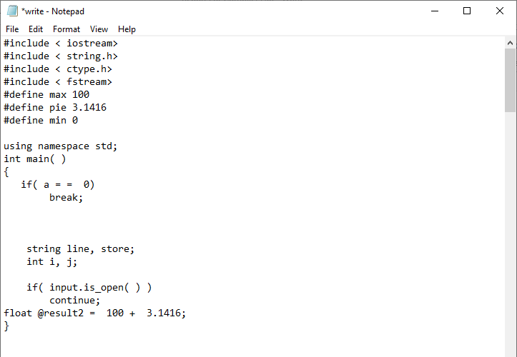

**Lab No- 04**

Problem Statement: Checking variables are valid or invalid and their data type.

Description: At first, we are taking a program as input using file system. We have declared a string type array which contain all data types name. To solve this problem, firstly we are separating words from a line in input program. Then we compare the word with the string type array which contain data types name. When a word will be matched, simply we increase the value of i for the space and will concate the characters in a variable after the space till next space. Then we check a condition, the first character of the last word which we putted in a variable. If the character is between ‘A’ – ‘Z’, ‘a’ - ‘z’, ‘$’, ‘*’ and ‘_’ then the word will be valid. That means the variable of the input program will be valid. If not, then the variable will be invalid. Then we just print the variable data type and valid or not.

Input:



Output:

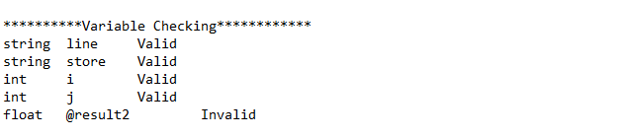

**Lab No- 05**

Problem Statement: print all the **keyword** using in a program as given input.

Description: At first, we are taking a program as input using file system. Then we have declared a string type array which contain all keyword in c++. To solve this problem we have to follow the previous working procedure. Firstly we have to separate all word in a line and every word will be compared with the array element. If matched, then we simply print that, this is a keyword.

Input:



Output:

